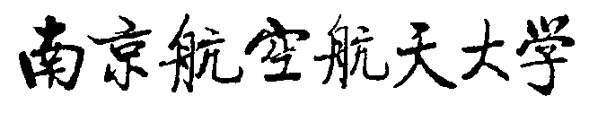

实验课程排课申请表

|  |  |  |  |  |  |  |
| --- | --- | --- | --- | --- | --- | --- |
| 课程名 |  | | | | | |
| 课程号 |  | 课程类型√ | [　] 带实验的理论课 [　] 纯实验课 | | | |
| 开课学院 |  | 讲课学时 |  | 实验学时 | |  |
| **排课要求** | | | | | | |
| 排课学时数 |  | 周学时 |  | 是否需要安排教室 |  | |
| 排课起止时间 |  | | | | | |
| 需要排课原因 |  | | | | | |
| 开课学院审定 | |  |  |  |  | | --- | --- | --- | --- | | 负责人签字（盖章）： |  | 日期： |  | | | | | | |